**Bug Reporting** (https://www.demoblaze.com/index.html)

**Pre- Requisite:** User must have the access to the Mentioned Website

**Workflow:** Open website link>Sign up Button>Cross icon

**Test Description:** Verify sign up button behave normal on closing the sign up pop up

**Steps to Reproduce:**

Open <https://www.demoblaze.com/index.html>

Click on the sign up button

Hit the cross icon to close the sign up pop up

Sign Up button Hides

**Actual Results:** Sign up button hides

**Expected Results:** Upon clicking on the cross icon sign up button must behave like other buttons

**Severity:** Normal

**Issue Type:** Functional

**Frequency:** Every Time

**Environment:** All browsers

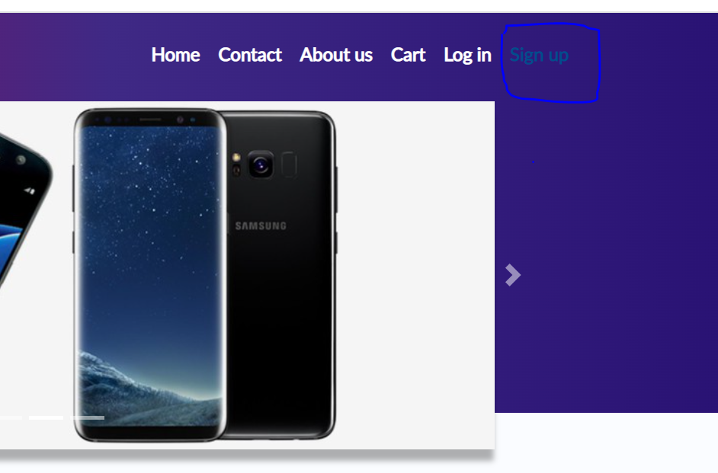

**Pre- Requisite:** User must have the access to the Mentioned Website

**Workflow:** Open website link>Log in>Contacts

**Test Description:** Verify system must take a valid Email in Contact Page

**Steps to Reproduce:**

Open <https://www.demoblaze.com/index.html>

Login into the application

Click on the Contact button

Enter in-valid Email ID

Enter other information

Hit the Send message button

**Actual Results:** Application accepts in-valid Email ID

**Expected Results:** Application must take just the valid Email ID as input like (abc@gmail.com)

**Severity:** High

**Issue Type:** Functional

**Frequency:** Every Time

**Environment:** All browsers

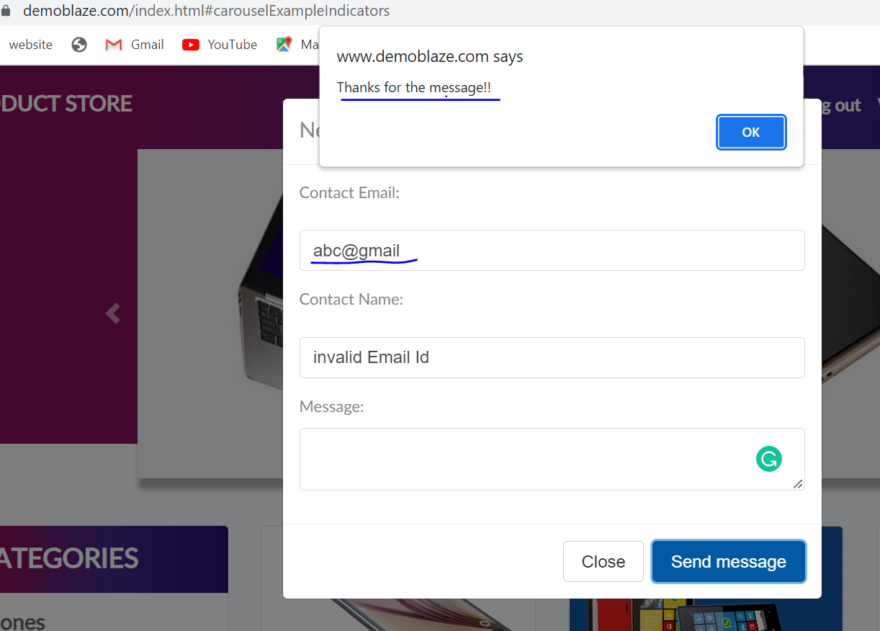

**Pre- Requisite:** User must have the access to the Mentioned Website

**Workflow:** Open website link>Log in>Contacts

**Test Description:** Verify system not accepts special characters in Name Field

**Steps to Reproduce:**

Open <https://www.demoblaze.com/index.html>

Login into the application

Click on the Contact button

Enter special characters in name field

Enter other information

Hit the Send message button

**Actual Results:** Application accepts special characters in name field

**Expected Results:** Application need not to take name field inputs as special characters

**Severity:** Normal

**Issue Type:** Functional

**Frequency:** Every Time

**Environment:** All browsers

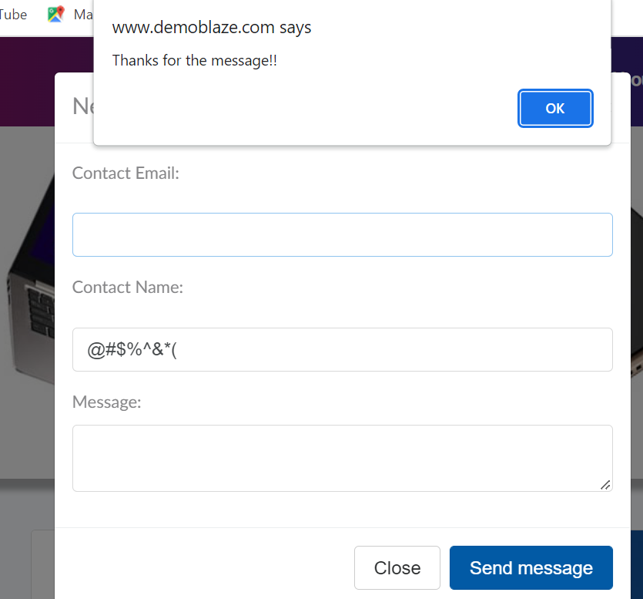

**Pre- Requisite:** User must have the access to the Mentioned Website

**Workflow:** Open website link>Log in>select any Item

**Test Description:** Verify that the application header alignment remains sync all the time

**Steps to Reproduce:**

Open <https://www.demoblaze.com/index.html>

Login into the application

Select any item

**Actual Results:** Header Alignment disturbs after selecting any item in the store

**Expected Results:** Header Alignment should be sync all the time

**Severity:** Normal

**Issue Type:** Functional

**Frequency:** Every Time

**Environment:** All browsers

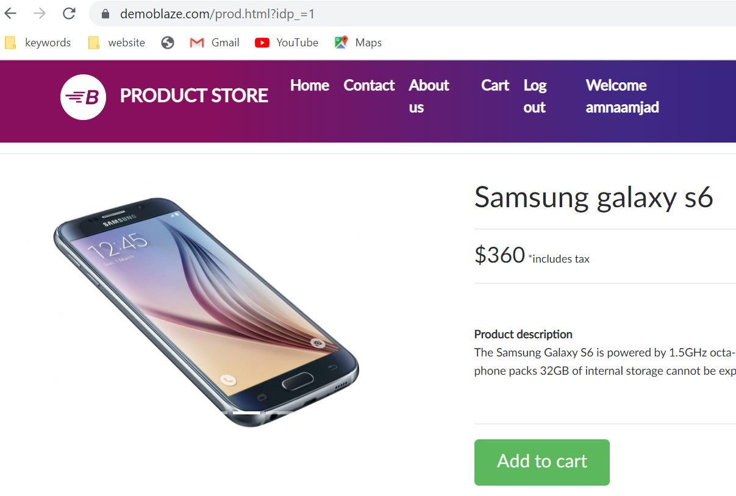

**Pre- Requisite:** User must have the access to the Mentioned Website

**Workflow:** Open website link>Log in>select any Item

**Test Description**: Verify that on adding Item from the store in cart then cart number must increase by one

**Steps to Reproduce:**

Open <https://www.demoblaze.com/index.html>

Login into the application

Select any item

**Actual Results:** On adding multiple or single item in cart the cart number not increases it remains same.

**Expected Results:** Cart number must the updated on adding item into cart every time

**Severity:** High

**Issue Type:** Functional

**Frequency:** Every Time

**Environment:** All browsers

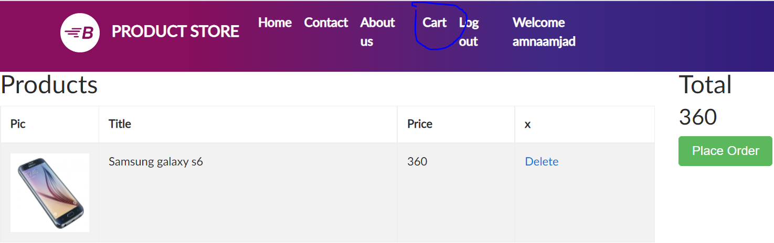

**Pre- Requisite:** User must have the access to the Mentioned Website

**Workflow:** Open website link>Log in>Cart

**Test Description:** Verify that the application must take the order with valid inputs

**Steps to Reproduce:**

Open <https://www.demoblaze.com/index.html>

Login into the application

Select any item

Go to the cart section

Hit the place order button

Enter any random values in card number and name field

Click on the purchase button

**Actual Results:** Application is accepting orders with dummy data

**Expected Results:** Application must need to take the order with real time data

**Severity:** High

**Issue Type:** Functional

**Frequency:** Every Time

**Environment:** All browsers

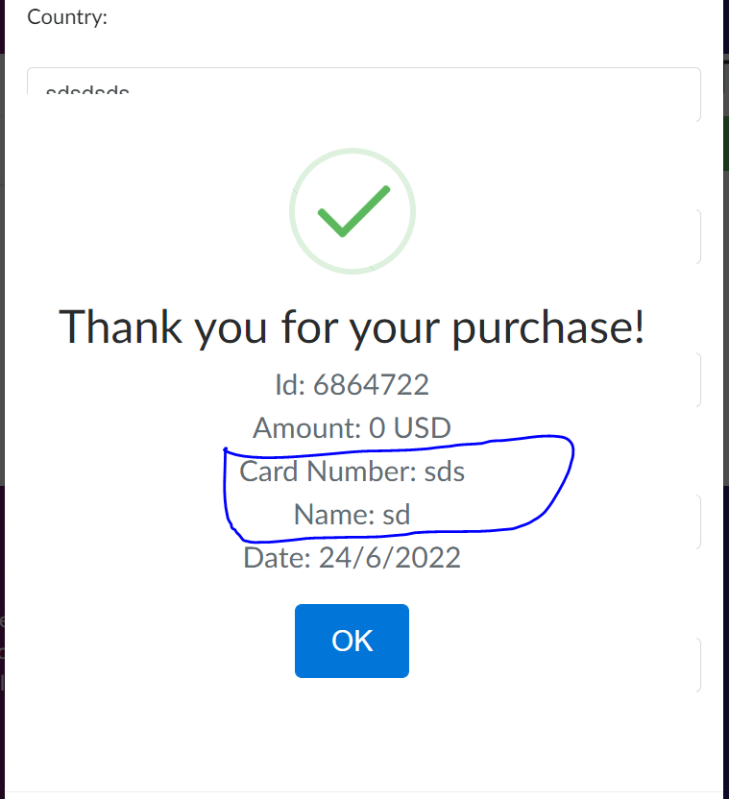

**Pre- Requisite:** User tries to post an order without selecting any item in the cart

**Workflow:** Open website link>Log in>Cart>purchase

**Test Description**: Verify that the application must take the order with when at least one item is present in the cart section

**Steps to Reproduce:**

Open <https://www.demoblaze.com/index.html>

Login into the application

Go to the cart section

Hit the place order button

Enter any random values in card number and name field

Click on the purchase button

**Actual Results:** Application is accepting order even when no item is present in the cart section

**Expected Results:** Application must need to place an order when at least one item is present in the cart section

**Severity:** High

**Issue Type:** Functional

**Frequency:** Every Time

**Environment:** All browsers

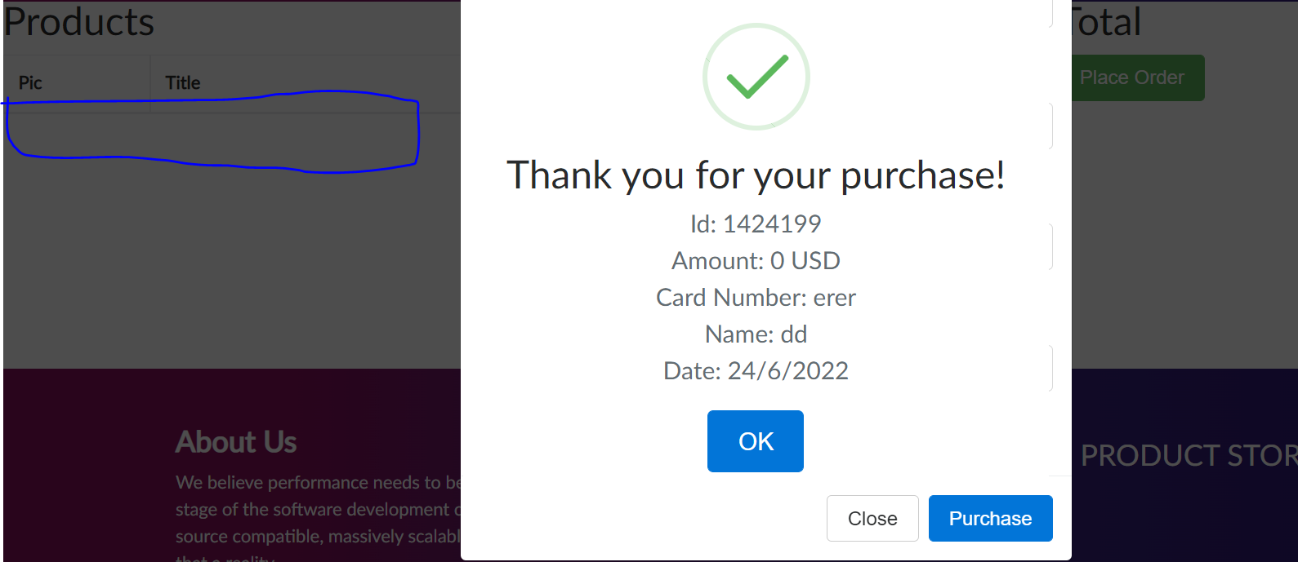

**Pre- Requisite:** User tries to post an order without selecting any item in the cart

**Workflow:** Open website link>Log in>Cart>purchase

**Test Description:** Verify that the application must close the purchase pop up on clicking the purchase button

**Steps to Reproduce:**

Open <https://www.demoblaze.com/index.html>

Login into the application

Go to the cart section

Hit the place order button

Enter any random values in card number and name field

Click on the purchase button

Order confirmation pop up opens but purchase pop up also remains open

While clicking on the purchase button a new order is placed with new order ID

**Actual Results:** Application keeps the purchase pop up open even after the opening of new Order confirmation pop up

**Expected Results:** Application must close the purchase pop up first then opens the order confirmation pop up

**Severity:** High

**Issue Type:** Crashing

**Frequency:** Every Time

**Environment:** All browsers

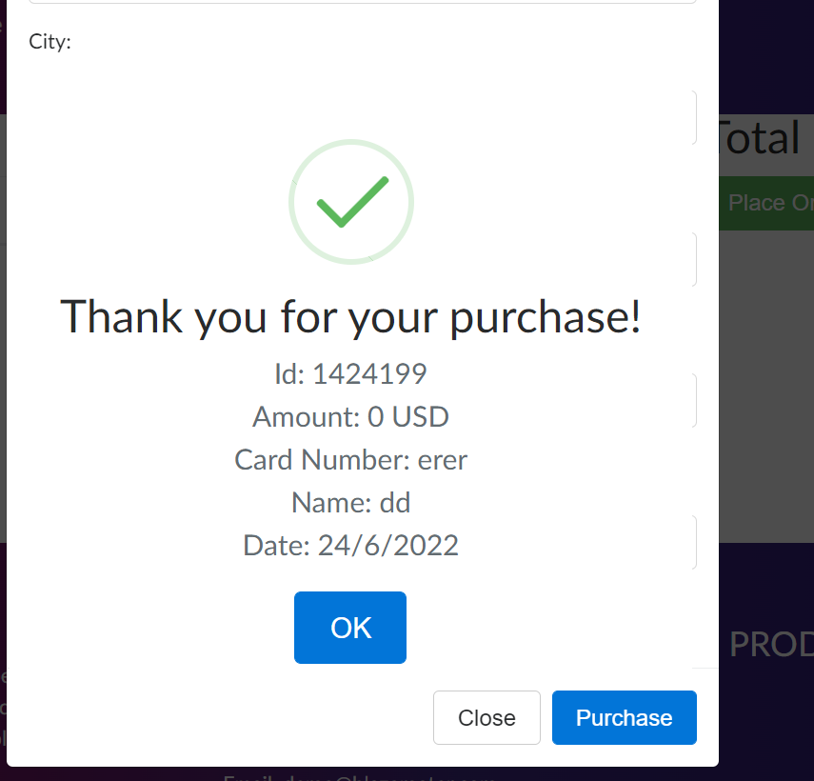

**Pre- Requisite:** User must have the access to the Mentioned Website

**Workflow:** Open website link>Log in>Cart>purchase

**Test Description:** Verify that the month and year fields in the purchase order pop up must accepts the numeric values

**Steps to Reproduce:**

Open <https://www.demoblaze.com/index.html>

Login into the application

Go to the cart section

Hit the place order button

Enter any alphabets in month and year fields

Click on the purchase button

**Actual Results:** Application is accepting the alphabets in the month and year fields

**Expected Results:** Application should accepts only the numeric values in month and year fields

**Severity: High**

**Issue Type: Functional**

**Frequency: Every Time**

**Environment: All browsers**

